**Appendices**

**Appendix A**

**Intercept Request Code**

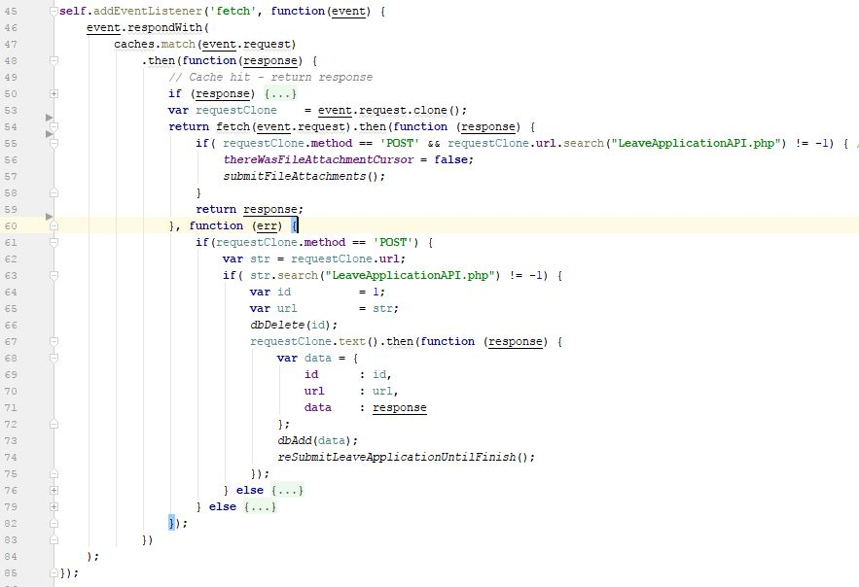

**Appendix B**

**Evaluation Form Sample Answers**

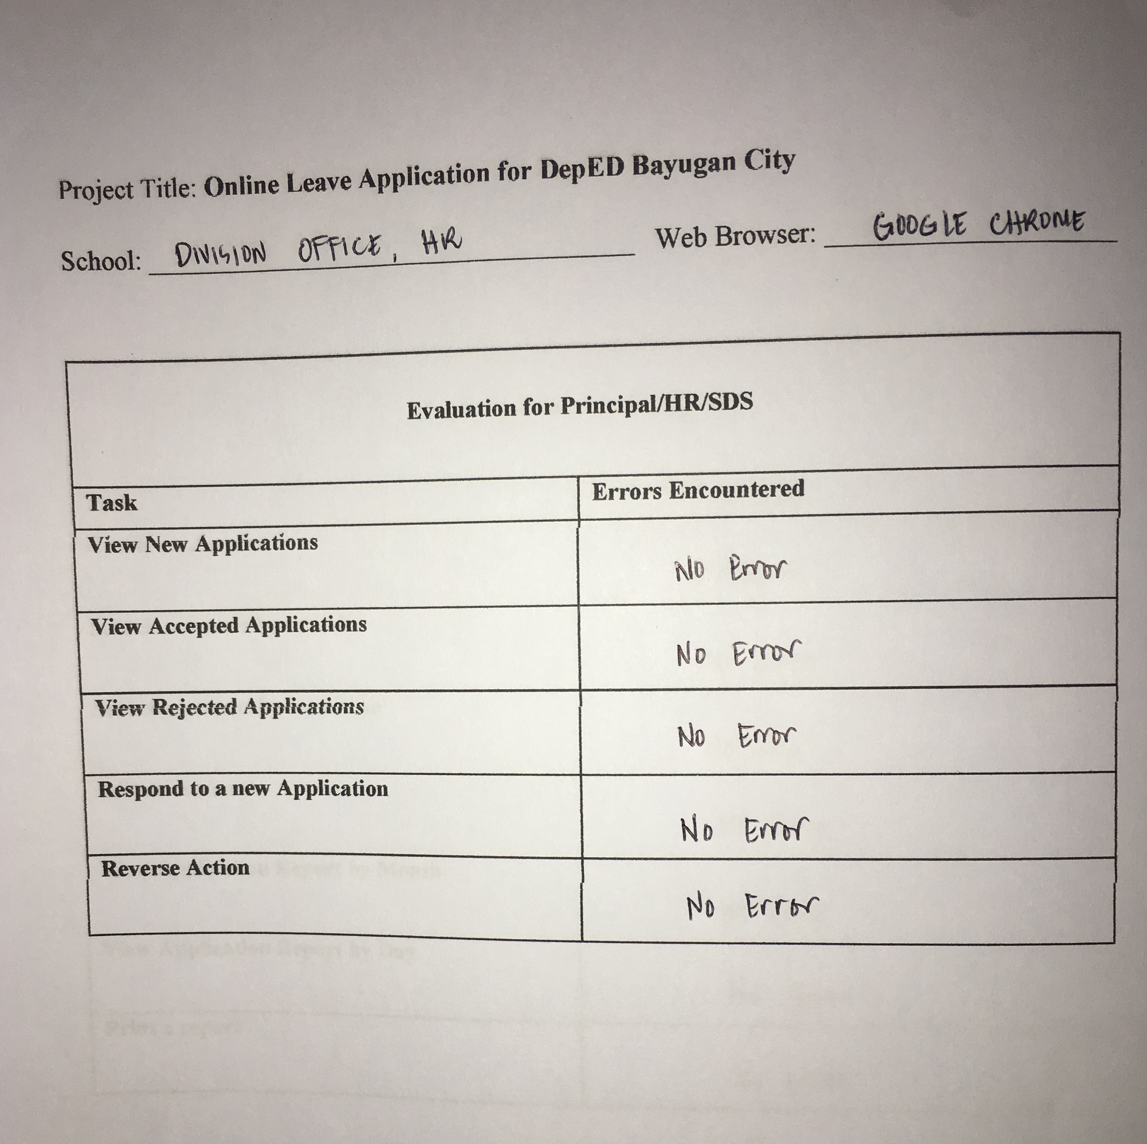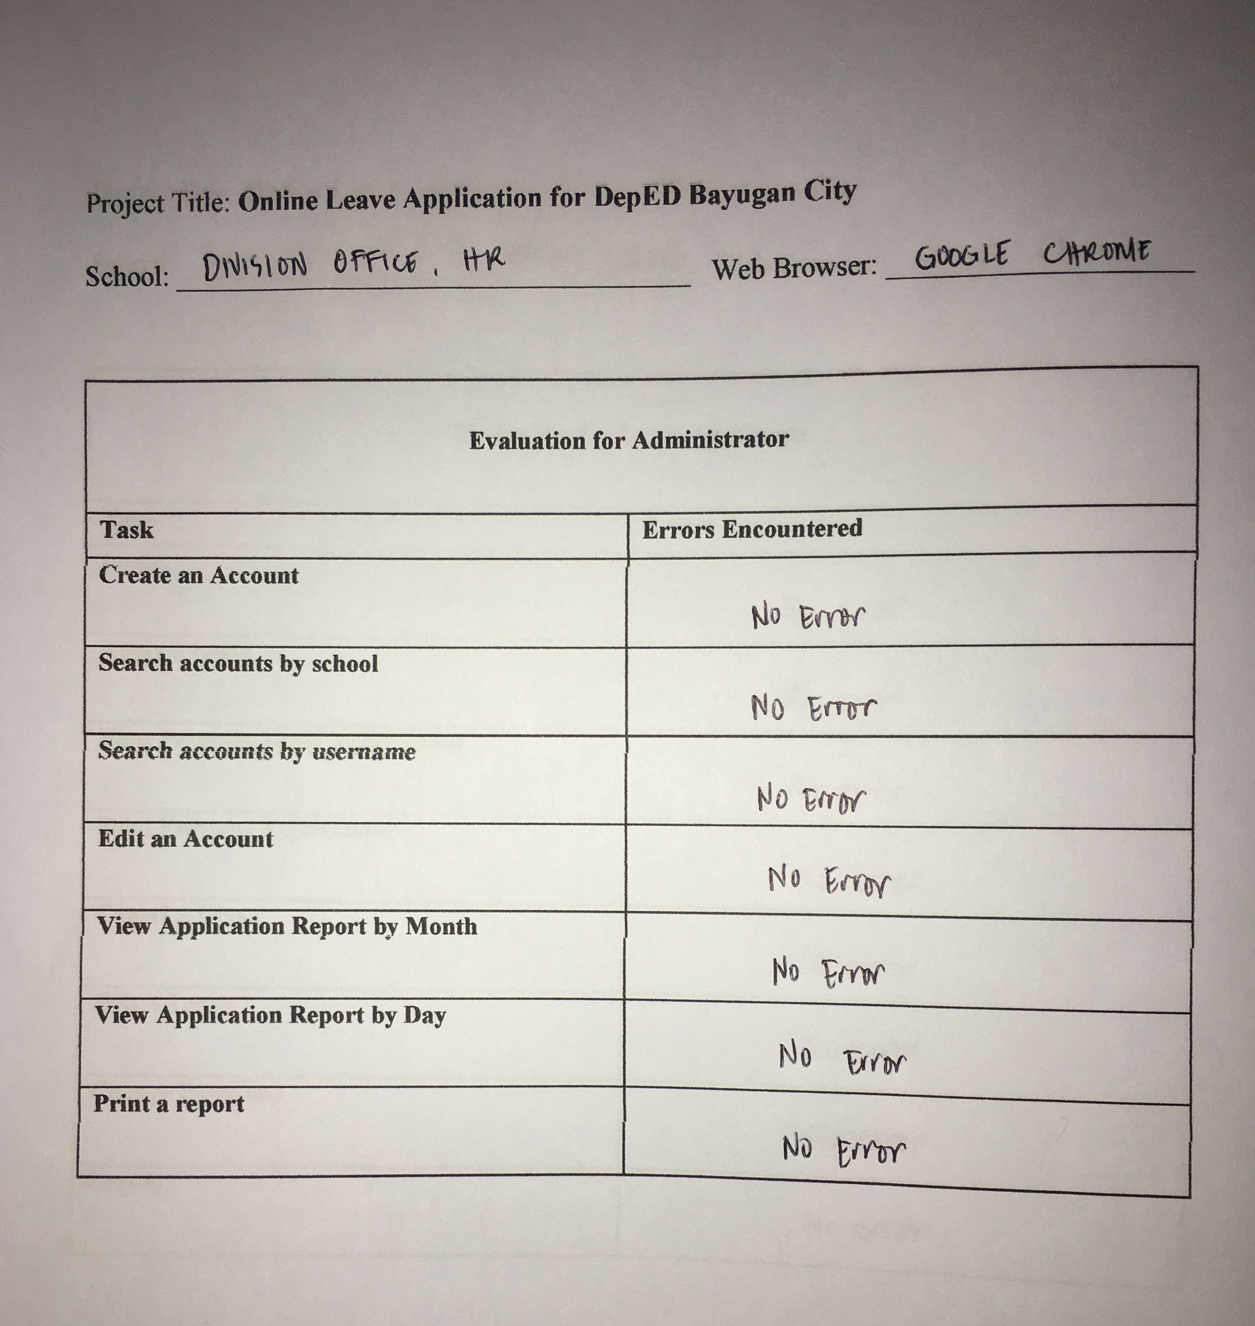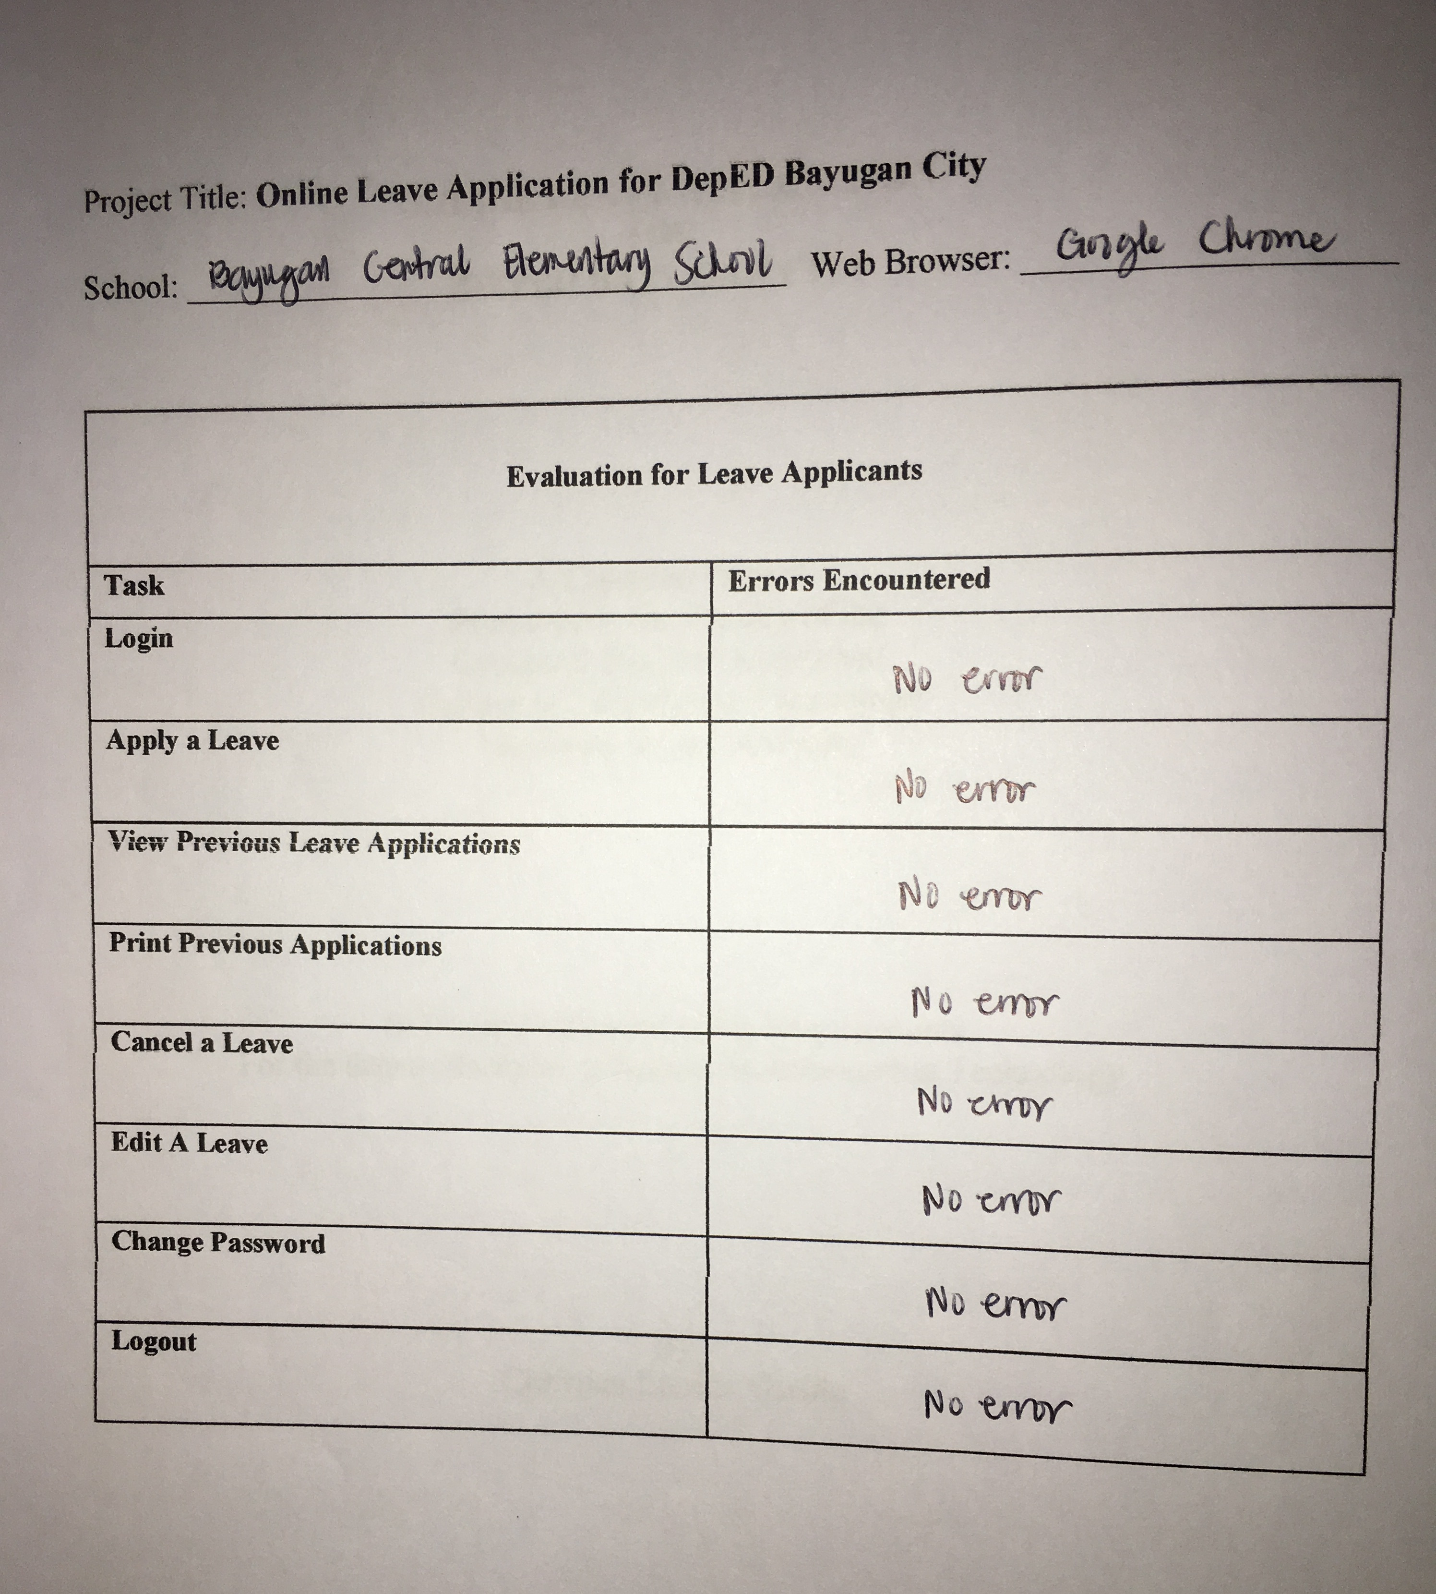

**Appendix C**

**User’s Manual**

**Leave Applicant Manual**

1. How can I apply for a leave?

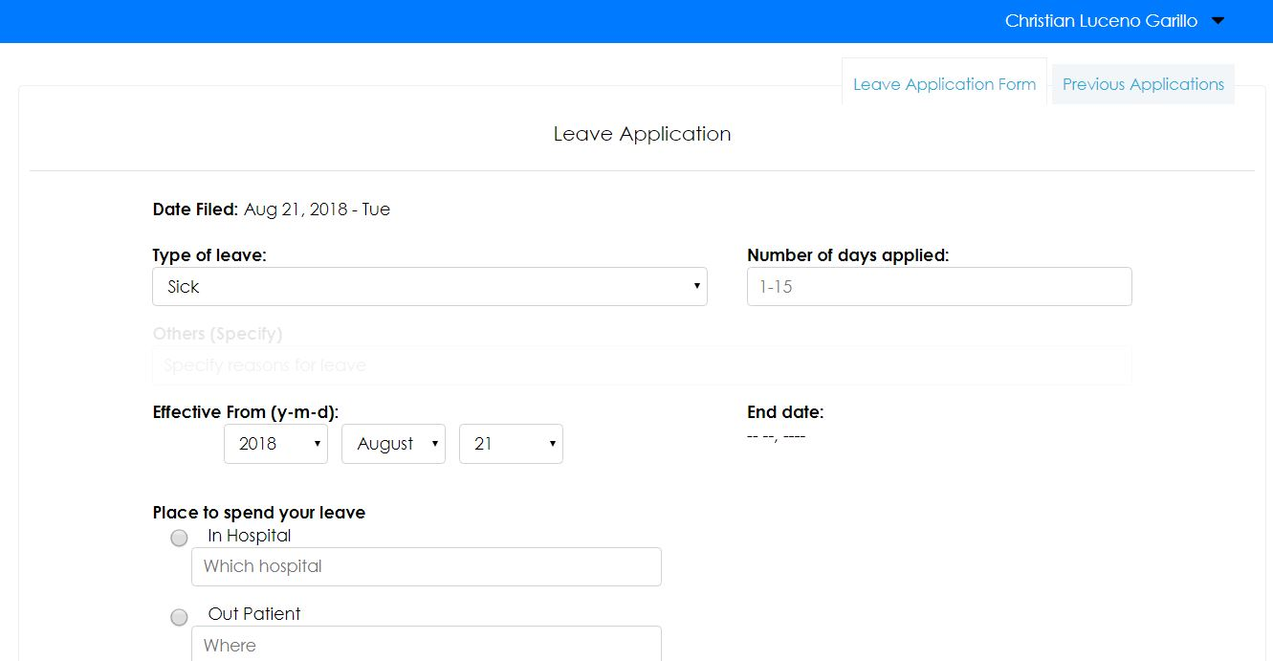

When someone logins, and the account type is “user”, the default page or the landing page will be the leave application form. With zero effort, you can find the leave application form in no time.

1. How can I see my application history?

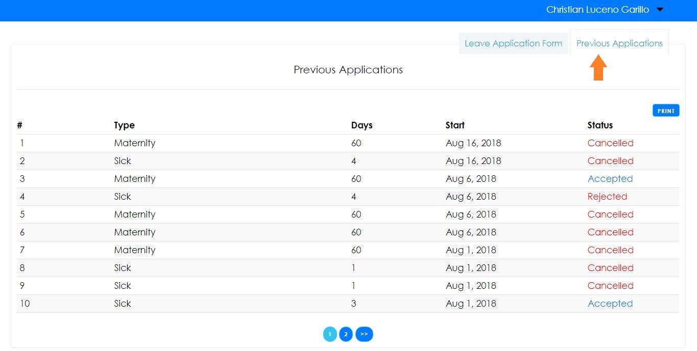

Navigate to the “Previous Applications” tab as shown in the image above. There you can see the history of your applications. It also clearly stated the status of your application in the status column in the table. But in order to see the details, you must click on the row.

1. How can I see the details of an application from the history?

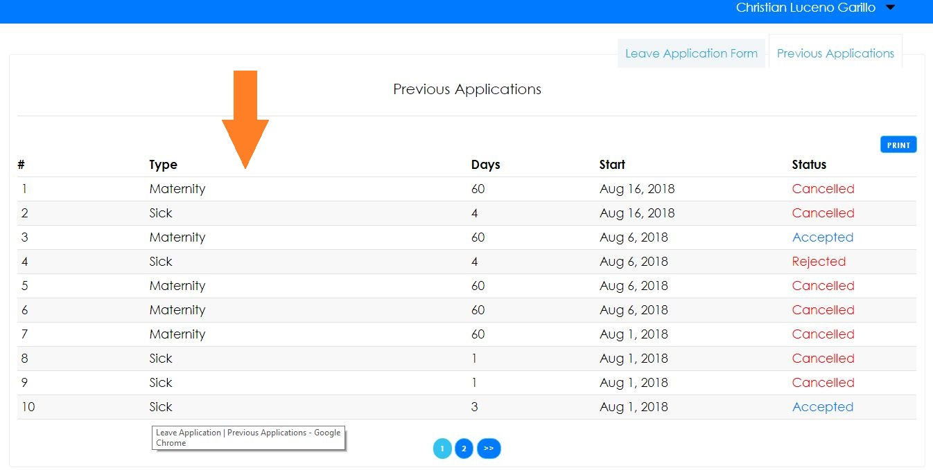

By clicking the rows in the table, you can see the details of each leave application from the previous applications tab.

1. How can I print my leave application history?

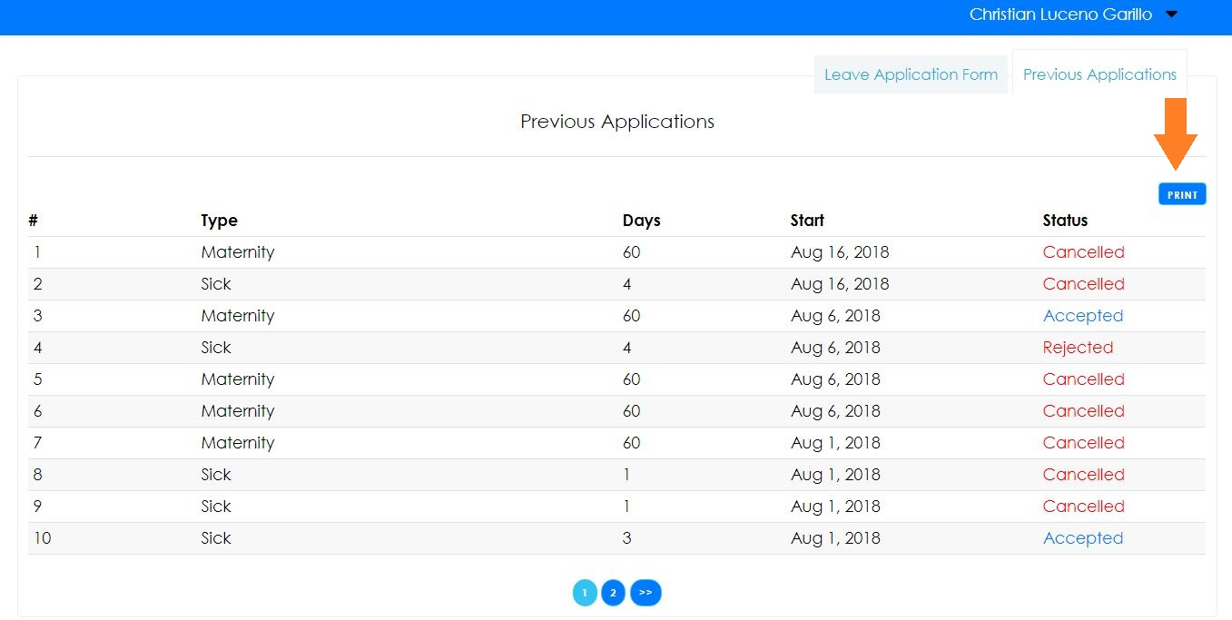

You can print your application history by clicking the print button shown in the image.

1. How can I logout my account?

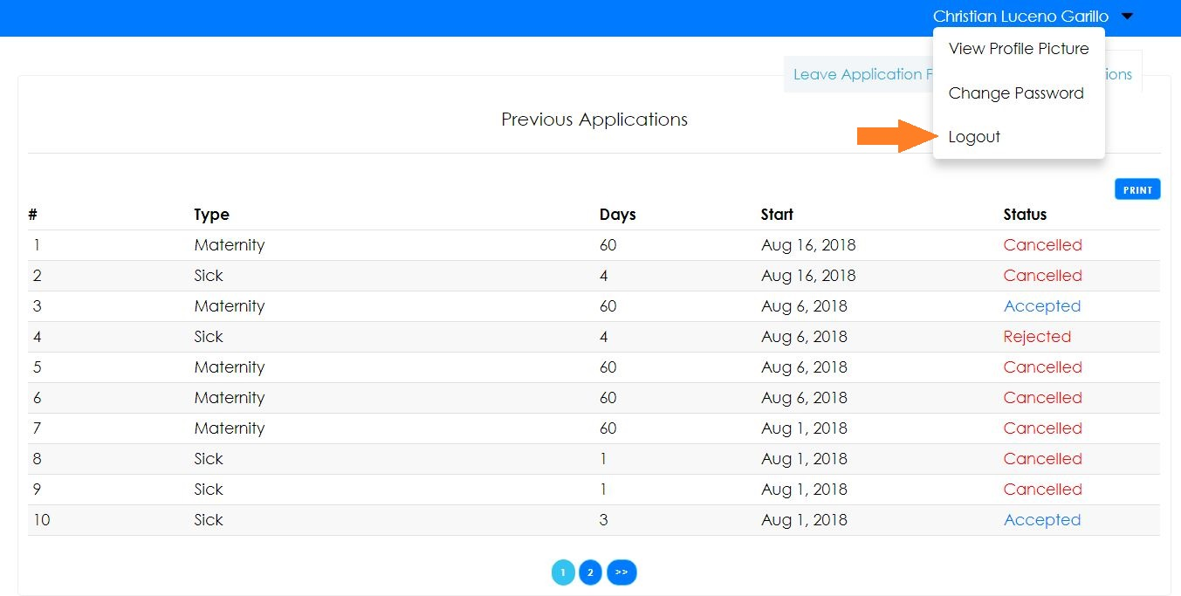

When you click in your name, a menu will appear, there you can see the logout link. Click on it and you’re done. You can also change your password and change your profile picture in the menu.

**Principal/HR/SDS Manual**

1. How can I see the new, rejected and accepted applications?

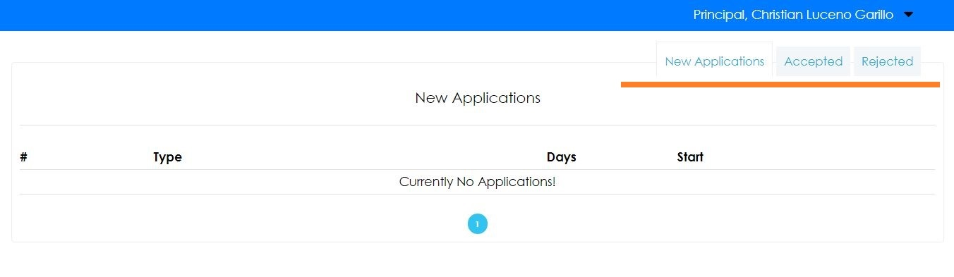

Depending on the tab clicked shown above, you can see the new applications, accepted applications and rejected applications.

1. How can I respond to the new applications?

When you click on an item in the table, you can see the details of that application, you can also respond to that application, reject, or accept the application.

**Admin Manual**

1. How can I create an account?

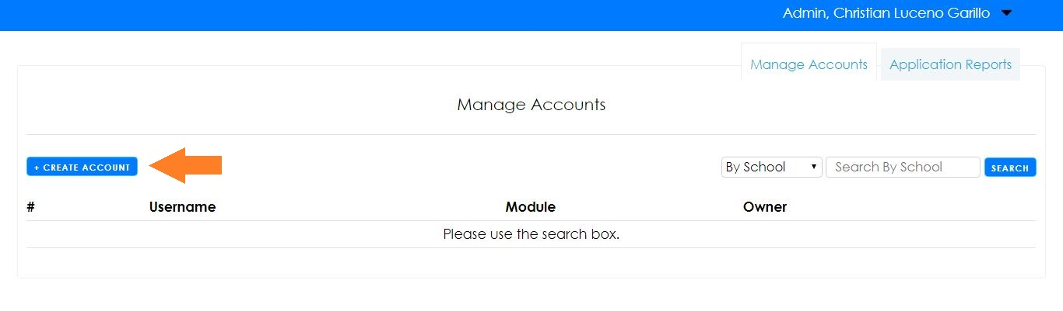

Click on the create account button as shown above. After clicking the button, you will see a form that will require you to enter account details.

1. How can I search for the accounts?

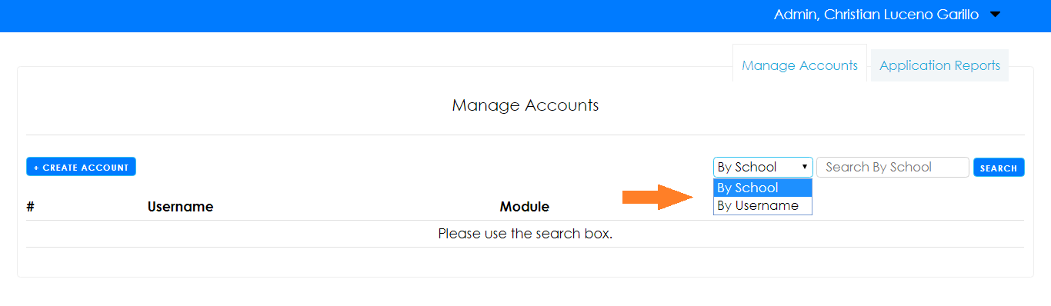

As shown above, there are 2 styles of search, you can search the accounts by username or by school. When you select by school, the list of schools will show in the search input fields that will look like a dropdown menu. If you chose to search by username, you can try input the username, and it will search the username that will match the input you provided.

1. How can I search all of the applications on a specific day?

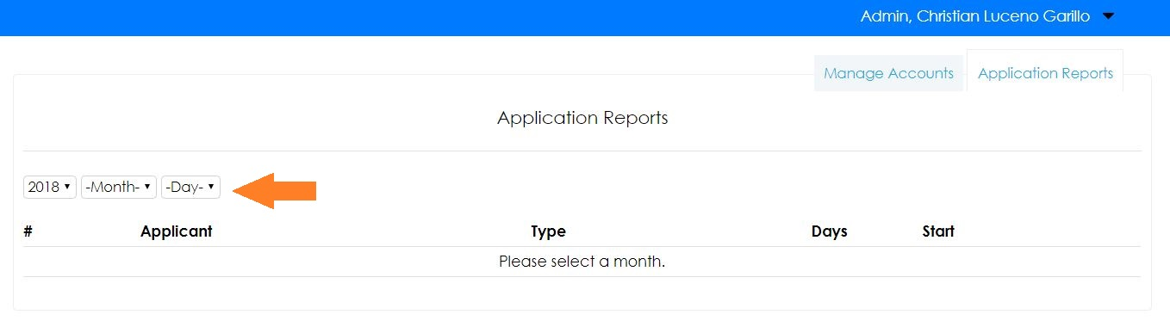

In order to see the applications on a specific day, you must select a date, year and month is required and not the day. You can see the applications by month, or by an specific day.

1. How can I print the leave applications?

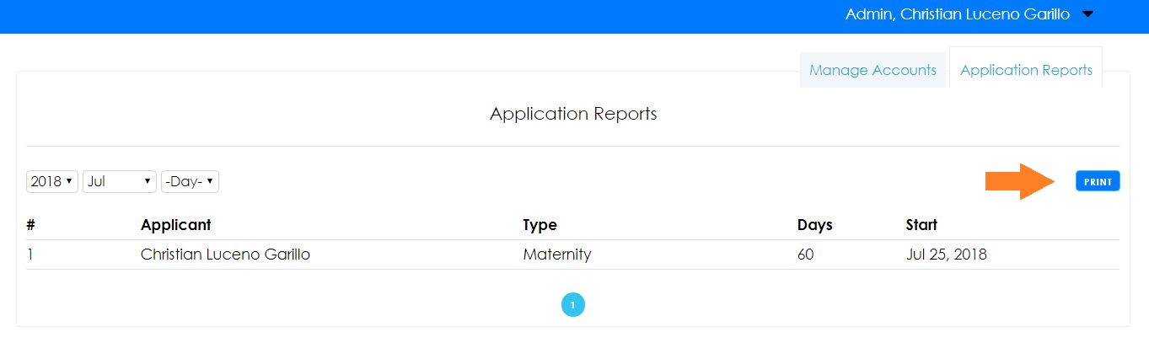

Once you’ve selected a date, the print button will appear as shown above. When you click the button, all of the applications that you can see on the date you’ve selected will be printed.

**Appendix D**

**Developer’s Curriculum Vitae**

  
Toog Street.

Bayugan City, 8502

09055-113-055

Christian201316927@gmail.com

Christian l. garillo

|  |  |  |  |  |
| --- | --- | --- | --- | --- |
| Skills & Abilities |  |  |  | **Programming Languages**  PHP, C++, Python, C#, C, Java  **Web Development Technologies**  HTML5, CSS3, Javascript  **Mobile Development**  **Android**  **Framework and Libraries**  Laravel, .NET, JQuery  **Database**  MySQL, PostgreSQL, FirebirdSQL, SQLite  **Multimedia**  GIMP, Sony Vegas Pro  **3D Modeling and Animation**  Google SketchUp, Blender, Unity  **Software Design and Analysis**  Human-Computer Interaction  **Operating System Platform**  Windows, Linux |
| Education |  |  |  | Mindanao state university - main BS Information Technology (Database Systems)  Tertiary Education Bayugan national comprehensive high school Secondary Education Bayugan central elementary school Elementary Education |
| Communication |  |  |  | English, Filipino, Cebuano |
| PRojects |  |  |  | **Online Thesis Repository**  Dedicated to save the to-be forgotten thesis of all students in MSU-Main  **CSSH Repo**  College of Social Sciences Repository for Mindanao State University Papers  **MSU-CIT Virtual Tour**  A first person virtual tour to MSU-College of Information Technology  **Smart Parking**  Automated parking space watcher and reservation.  **Leave Application Online for DepED Bayugan City**  Online leave application available 24/7 for convenience of the teachers. |
| Awards and recognition |  |  |  | **Champion,** Open Programming Competition  MSU-CIT Foundation Celebration, Marawi City, Aug. 8, 2014  **Champion,** Open Programming Competition  14th Iligan City Computing Fair, Iligan City, November 23-25, 2016  **2nd Runner Up,** Open Programming Competition  6th PSITS Regional Convention, Sultan Kudarat, September 27, 2014  **Champion,** Open Programming Competition  9th PSITS Regional Convention, Sultan Kudarat, October, 2017 |
| References |  |  |  | Jofil Almendra Israel Computer Studies Department, Faculty, MSU-Marawi  09102900024 Siegfred Balasa Pagador Information Systems Department, Programmer, MSU-Marawi  09305483244 |